Ref: TMT/ Agra/S0468/2025 03.10.2025

To,
Jai Hanuman Engineering Industries,
Mobile: 9897417442
Agra.

Dear sir,

Sub :- Supply of HYDRAULIC PRESS BRAKE MACHINE.

Thank you very much for your enquiry regarding your requirement of hydraulic press brake. We are glad to inform you that we would be in a position to supply you the required equipment. Given below are the required specifications and description of the machine and our terms and conditions.

PRESS BRAKE :

1) Size : 2500 X 6 M.M.

2) Tonnage : 110 M.T.

S No | Description of the unit | Offer
1. | Hydraulic Press Brake with bending capacity 2.5 Meters and 6 mm MS 110 MT load capacity with Power pack of 7.5HP motor along with one set Standard Die and Punch. | Rs 7, 50,000/-  (Rupees Seven Lakhs Fifty Thousand Only)
2. | With NC Back Guage | Rs 1,75,000/-  (Rupees One Lakhs Seventy-Five Thousand Only)

SPECIFICATIONS FOR THE HYDRAULIC PRESS BRAKE MACHINE WITH 2500 M.M. WIDTH AND 6 M.M. THICKNES.

1. Tonnage : 110 M.T.

2. Clearance between Housings : 2000 M.M.

3. Bending capacity in M.S : 2500 x 6 M.M

4. Ram stroke. : 150 M.M.

5. Open height. : 350 M.M.

6. Closed height. : 200 M.M.

7. Depth of Throat. : 300 M.M.

- Ram speeds.

a) Approach. : 22 M.M. per Sec.

b) Pressing. : 3 M.M. per Sec.

c) Return. : 40 M.M. per Sec.

9. Motor capacity. : 7.5 H.P. (Crompton)

10. Punch. : 2500 x 185 x 45 M.M.
( ‘GROOSE NECK’ type)

11. Bed size. : 2500 x 225 x 60 M.M.

12. Cost of Machine. : Rs. 9,00,000/- + Taxes.

13. Mode of payment. : As per the quotation.

14. Delivery. : As per the quotation.

GENERAL TERMS & CONDITIONS:

- Price quoted per unit ex-work. Hyderabad.
- Following charges are additional to your account.
- Freight Charge : As actual to be borne by you.
- Sales Tax : 18 % Extra as applicable
- Packing charge : As actual to be borne by you.
- Insurance : As actual to be borne by you.
- Payment : 50% advance along with order balance before delivery but after inspection at our works.
- Delivery : within 6 weeks
- Validity : One month from the date of submission.
- Inspection : Inspection at our works prior to dispatch.
- Warranty : The machine is warranted for a period of 12 months from the date of dispatch against any manufacturing defects/ faulty material or bad workmanship of any part or component but not against any kind of abnormal or improper use of machine. Defective part or component will be replaced or repaired free of cost. Electrical components are outside the scope of this warranty.
- Commissioning : Erection & commissioning done by you, but required technical support & guidance provide by us at additional cost.

NOTE:
- Oil is not in scope of our supply.
- Raw material for trial is to be arranged by you at your cost.

We are sure you will find our offer in line with your requirements. Should you require any further clarification please contact 9246221106
Thanking you and assuring you of our best services

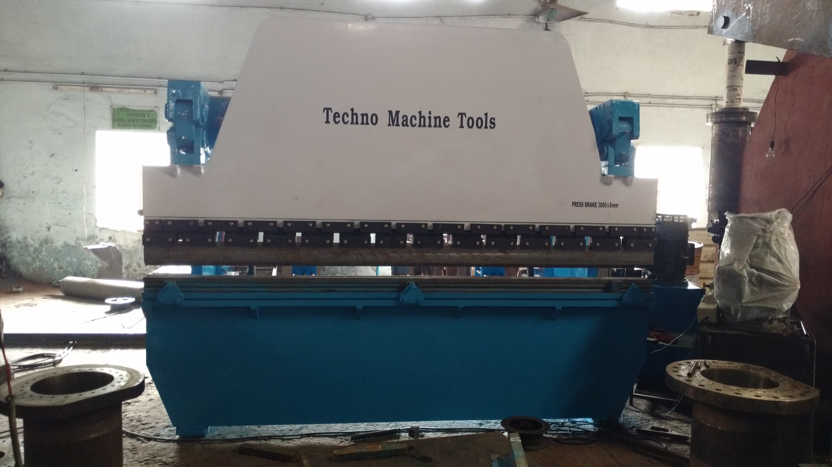

For TECHNO MACHINE TOOLS

(T. SIVARAMAKRISHNA)

Ref: TMT/ Agra/S0468/2025 03.10.2025

To,
Jai Hanuman Engineering Industries,
Mobile: 9897417442
Agra.

Dear Sir,

Sub :- Supply of Three Roller Plate Bending machine

We thank you for your inquiry regarding Plate Bending machine for MS plate width 2500 and thickness 6 mm. We are glad to inform you that we would be in a position to do the required equipment. Given below are the specifications and description of the machine and our terms and conditions.

S No | Description of the unit | Offer
1. | Supply Three Roller Plate Bending machine for 2500 X 6 MM along electrical. | Rs 3,50,000/- (Rupees Three Lakh Fifty Thousand Only)

Specifications of the equipment

1) Maximum width of the plate that can be rolled : 2500 MM

2) Maximum thickness of the plate that can be rolled : 6 MM

3) Top Roll diameter : 200 MM

4) Bottom Roller Diameter : 177 MM

5) Minimum Rolling Diameter : 370 MM

6) Rolling speed : 3.0 Meters/Min.

7) Maximum yield limit of the plate : 245 Mpa.

8) Total power : 15 HP

GENERAL TERMS & CONDITIONS:

- Price quoted per unit ex-work. Hyderabad.
- Following charges are additional to your account.
- Freight Charge : As actual to be borne by you.
- Sales Tax : 18 % Extra as applicable
- Packing charge : As actual to be borne by you.
- Insurance : As actual to be borne by you.
- Payment : 50% advance along with order balance before delivery but after inspection at our works.
- Delivery : With 50% advance 1.5 months from date of advance received
- Validity : One month from the date of submission.
- Inspection : Inspection at our works prior to dispatch.
- Warranty : The machine is warranted for a period of 12 months from the date of dispatch against any manufacturing defects/ faulty material or bad workmanship of any part or component but not against any kind of abnormal or improper use of machine. Defective part or component will be replaced or repaired free of cost. Electrical components are outside the scope of this warranty.
- Commissioning : Erection & commissioning done by you, but required technical support & guidance provide by us at additional cost.

NOTE:
- Oil is not in scope of our supply.
- Raw material for trial is to be arranged by you at your cost.

We are sure you will find our offer in line with your requirements. Should you require any further clarification please contact T.SIVARAMAKRISHNA 9246221106/9849207176

Thanking you and assuring you of our best services.

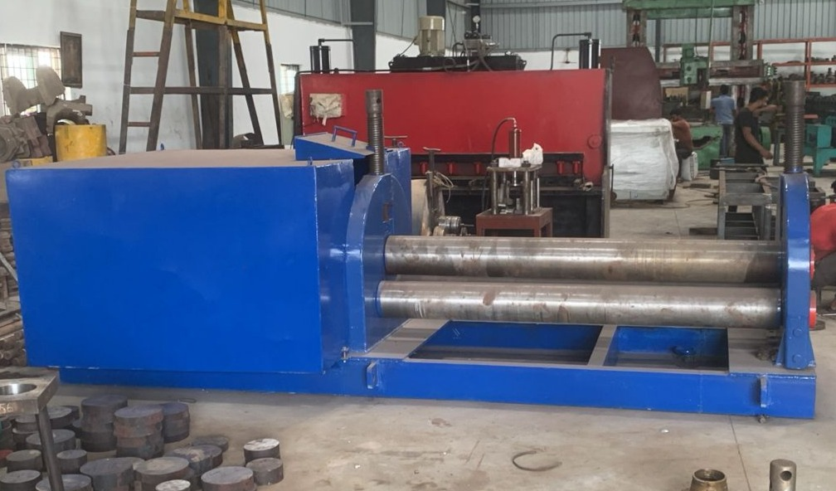

For TECHNO MACHINE TOOLS

( T. SIVARAMAKRISHNA)

Ref: TMT/ Agra/S0468/2025 03.10.2025

To,
Jai Hanuman Engineering Industries,
Mobile: 9897417442
Agra.

Dear Sir

SUB :- SUPPLY OF 50 MT HYDRAULIC PRESS

With reference to our discussions regarding your requirement for press. we are glad to inform you that, we are in a position to supply you the required equipment. The following are the specifications and our terms and conditions.

Specifications of the equipment

- AUTOMATION GRADE : Semi Automatic
- MATERAIL : Mild Steel
- MACHINE DIMMENSSIONS : 1710X870X1610MM (LxWxH)
- WEIGHT : 3200
- POWER : 10 HP
- KNOTCHING THICKNESS : 10 MM
- MACHINE CAPACITY : 60 TON
- USAGE AND APPLICATION : CHANNEL, ANGLE, FLAT ETC

Product Description
We are offering 50T Hydraulic Iron Worker to our clients.
Salient Features:
- TMT Hydraulic Iron Worker is designed to give an effective solution to all the cutting & punching problems of flat and Section with satisfactory work quality from robust and compact machine
- Unique compact design by using ultra-sonically tested steel plates
- Five work station catering '7' different operation
- International brands hydraulic & electrical components ensure trouble free operation
- Sequential operation of punching station with other work station
- Direct shearing avoids any waste of materials
- Hydraulic Holding Cylinder for Material Holding. (Shearing / Angle & Punching Station)

Specifications of the equipment

Technical Specifications :-

❖ Max Working Pressure - 250 Kg/cm2
❖ Normal Working Pressure - 200 Kg/cm2
❖ Design Pressure - 250 Kg/Cm2
❖ Tonnage at 200 Kg/cm2 - 50 Tons
❖ Cyl Bore - 160 mm
❖ Rod Dia - 60 mm
❖ Stroke - 80 mm
❖ Mtg - Front Flange
❖ Approach Speed - 16 mm/sec
❖ Pressing Speed - 0-5 mm/sec
❖ Return Speed - 25 mm/sec
❖ HP - 10 HP
❖ Tank Cap - 120 Ltr

Detail Bill of Material

❖ Cylinder Seals - Imported German Seals ( Merkel or Halite )
❖ Motor - ABB / Siemens / Kirloskar / Crompton
❖ Rod Seal - Imported halite Seal
❖ Valves - Yuken / Polyhydron / Hydrotech
❖ Check Valves - Polyhydron
❖ Hydraulic Pump - Yuken / Dowty
❖ High Pr Pump - Polyhydron
❖ Bell Housing - Micro
❖ Relief Valves - Polyhydron
❖ Hyd Tank - Micro
❖ Hyd Tank - MHPL
❖ Fitting - Hyloc / Hydair
❖ Gasket - Champion
❖ Fastners - TVS / LPS

S No | Description of the unit | Offer
1. | Iron worker with 50ton capacity along with complete electrical and along with 10 hp motor | Rs 6,50,000=00

GENERAL TERMS & CONDITIONS:

1. Price quoted per unit ex-work. Hyderabad.
- Following charges are additional to your account.
- Freight Charge : As actual to be borne by you.
- Excise : Extra As Applicable
- Sales Tax : Extra as applicable
- Packing charge : As actual to be borne by you.
- Insurance : As actual to be borne by you.
- Payment : 50% advance along with order balance before delivery but after inspection at our works.
- Delivery :With 50% advance 2 months from date of advance received
- Validity : One month from the date of submission.
- Inspection : Inspection at our works prior to dispatch.
- Warranty : The machine is warranted for a period of 12 months from the date of dispatch against any manufacturing defects/ faulty material or bad workmanship of any part or component but not against any kind of abnormal or improper use of machine. Defective part or component will be replaced or repaired free of cost. Electrical components are outside the scope of this warranty.
- Commissioning : Erection & commissioning done by you, but required technical support & guidance provide by us at additional cost.

NOTE:
- Oil is not in scope of our supply.
- Raw material for trial is to be arranged by you at your cost.

We are sure you will find our offer in line with your requirements. Should you require any further clarification please contact 9246221106

Thanking you and assuring you of our best services

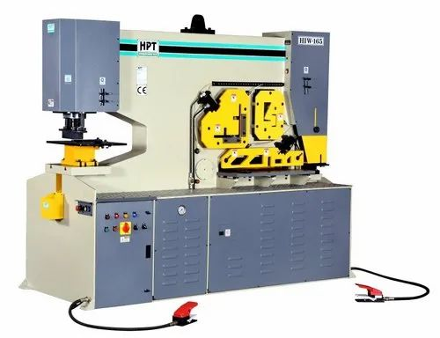

For TECHNO MACHINE TOOLS

( T.SIVARAMAKRISHNA)

